Contents
Home 2
About 2
Why Go Digital? 3
Rates 5
Idea Centre 5
Billboard map 6
Billboard Listings 6
Real estate (landowners) 6
Art work 6
Pay now 7
Contact 7

C: 512.787.2375
P: 512.306.1163
F: 512.306.1164
info@burkettmedia.com
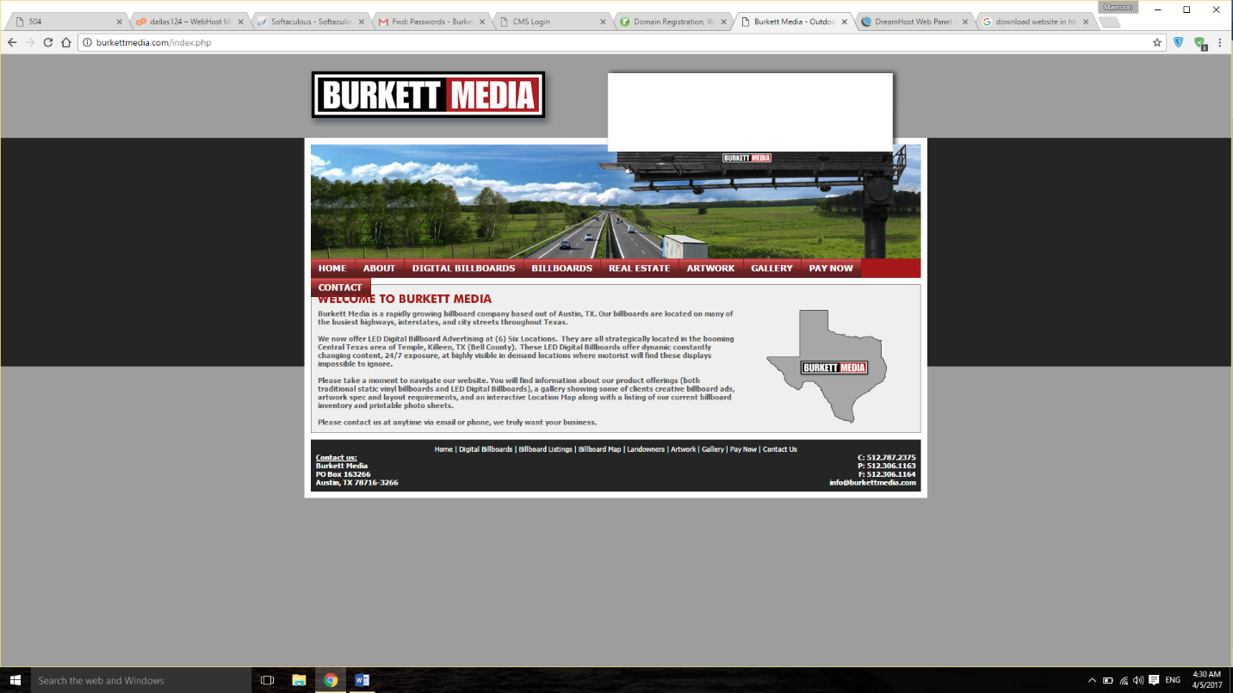
Contact us:
Burkett Media
PO Box 163266
Austin, TX 78716-3266

Home
WELCOME TO BURKETT MEDIA
Burkett Media is a rapidly growing billboard company based out of Austin, TX. Our billboards are located on many of the busiest highways, interstates, and city streets throughout Texas.
We now offer LED Digital Billboard Advertising at (6) Six Locations. They are all strategically located in the booming Central Texas area of Temple, Killeen, TX (Bell County). These LED Digital Billboards offer dynamic constantly changing content, 24/7 exposure, at highly visible in demand locations where motorist will find these displays impossible to ignore.
Please take a moment to navigate our website. You will find information about our product offerings (both traditional static vinyl billboards and LED Digital Billboards), a gallery showing some of clients creative billboard ads, artwork spec and layout requirements, and an interactive Location Map along with a listing of our current billboard inventory and printable photo sheets.
Please contact us at anytime via email or phone, we truly want your business.

About
History
Burkett Media’s founder, Beau Burkett, saw outdoor advertising as a definite career path at an early age. His parents owned and operated several businesses while raising Beau throughout his childhood. His parents success and drive taught Beau the keys to running a successful business that gave him the inspiration to start his own company that led to Burkett Media's formation.
While attending college at Texas State University on a golf scholarship, Beau acted on his entrepreneurial passion and started his first billboard company at the age of 18. He quickly built it up and sold for a profit just one year later. This led to the formation of Beau Burkett Media, LP (Burkett Media) in early 2003. After completion of his undergraduate degree in business management, Beau Burkett gained acceptance to and completed the pursuit of his MBA in Entrepreneurship at the Acton School of Business. Beau, now along with the help of his wife Lauren, will continue to enhance the size of Burkett Media and its offering to businesses like yours.
What We Do Best
Burkett Media takes pride in 110% customer satisfaction. After all, how can we expect to grow without satisfied advertisers and landowners? Upon our entry into the billboard industry we found a problem that needed to be addressed. Many cities and major highways throughout Texas are dominated by only one outdoor advertising company. This has led to incredibly high advertising rates and poor customer service. We target these markets and develop premium billboards on highways, interstates, and the busiest city streets. We then offer local and national businesses more affordable rates and the fastest artwork turnaround time.
What's Burkett Media's Plan?
Burkett Media is now more aggressive than ever and want you to be a part of it. We have the resources, knowledge, ambition and strategic plan in place to rapidly expand throughout Texas, not only in the markets we currently serve, but also in many other underserved, medium sized markets.
Contact Us
Please feel free to contact us anytime via email or phone. We will gladly provide you with contact information for satisfied clients, landowners, suppliers, and any of our associates.
Thanks again for giving Burkett Media a chance, we truly want to be a part of your growing buiness.

Why Go Digital?

In an increasingly digital world, sometimes print just isn't enough to catch your audience's attention. LED Digital Billboards are the future of out-of-home advertising. Utilizing the newest technology, Digital Displays are computer controlled electronic billboards that transmit light through the use of Light Emitting Diode (LED) technology allowing multiple ads to run daily and change in seconds from the click of a mouse transmitted wirelessly through the internet.

Digital displays are quickly becoming the hottest medium for cost-effective, high-impact out-of-home advertising. With the ability to change your creative immediately, digital displays keep your creative up-to-the-moment and allow you to target your customers with the most time-relevant message. See our Idea Center link for a list of how many different industries and businesses can dynamically utilize Digital Billboards.

Advantages vs Traditional Vinyl Billboards?

Digital Billboards compete directly with TV, Newspaper, and Radio. Why use your advertising budget on media outlets that can be ignored? TV commercials can be ignored with the popularity of DVR, TiVo. Radio is ignored due to the both Satellite Radio and in car iPod, MP3 usage. Newspaper subscribership has rapidly declined as people turn to the web. Digital Billboards can't be ignored! A captive audience sees our ads 24/7. Lastly, you get more bang for your buck (Outdoor has the lowest CPM available).

Digital Billboard Locations

Digital Billboard #1: Hwy 190 in Harker Heights, TX - Left Read, Facing East

Burkett Media offers the ONLY 14' x 48' Digital Billboard in the Killeen, Ft. Hood metropolitan market. The sign is located on Hwy 190 @ Modoc Drive on the south side of Hwy 190 between Knights Way and Stan Schlueter Loop. The visibility of this westbound visible face is unrivaled, as the road curves the sign face is a "head-on view" for over 30 seconds with no obstructions at all, making this the best billboard face in the entire market. This digital billboard face is visible to almost 100,000 cars per day and is located between the new Market Heights Shopping Center and Killeen / Ft. Hood Base.

Digital Billboard #2: Clear Creek Road in Killeen, TX - Left Hand Read facing North

The sign is located in the booming west end of town on Clear Creek Road at the entrance to Metroplex Hospital and near Texas A&M Central Texas University. This digital face is visible to traffic heading southbound on Clear Creek Road coming out of Ft Hood's Clear Creek Military Gate, to all traffic exiting off of Hwy 190 headed south into town, and all local traffic headed to the high school, new retail areas, and the new Killeen regional airport. This sign is located at a curve in the road as well giving it a "head-on view" and is also visible from the Watercrest Road stoplight along with the traffic going only 30mph this sign is as visible as it gets.

Digital Billboard #3: Clear Creek Road in Killeen, TX - Right Hand Read Facing South

The sign is located in the booming west end of town on Clear Creek Road at the entrance to Metroplex Hospital and near Texas A&M Central Texas University. This digital face is visible to traffic heading northbound on Clear Creek Road going to Metroplex Hospital, TAMU Campus, Ft. Hood Main Gate and Hwy 190. This is also viewed from all major retail centers, housing developments, schools and the new Killeen airport. A new stoplight just installed guarantees extra long exposure of clients ads.

Digital Billboard #4: HK Dodgen Loop @ I-35 Temple, TX - Right Hand Read Facing West

The sign is located at the busiest intersection in Temple, TX. Reading to both HK Dodgen Loop traffic driving eastbound to the Temple Mall and all major retail as well as all the access road traffic and stoplights below for I-35 (General Bruce) and Loop 363 (HK Dodgen Loop). This digital face is strategically located in a spot visible to thousands of cars at multiple stoplights and the busy traffic of the newly constructed intersection of HK Dodgen and I-35. This sign is impossible to ignore and is our newest digital offering!

All digital faces have either 8-second or 10-second spots that are displayed once every minute and approximately 1440 times per day. Pricing and programs fit all budgets and cater to every clients needs. Differing from traditional static billboards, we can get you up and running the same day and offer the unique opportunity to run timely relevant ads that can be changed and added / removed as you see fit free of charge. Please visit our Rates and Info link for pricing and available programs.

Rates
Please call (512) 787-2375 for information on plans, rates, terms and more info on our Digital Billboard.
Thanks,

Burkett Media

Idea Centre
Dynamic Ideas: How to Use Digital
Banks & Financial Institutions: Display up to date information regarding Checking & Savings Accounts, Car Loans, Mortgage Rates, CDs, IRAs, etc. Promote your Online Banking Service, Free Checking, Bill Pay & More! Advertise all local branches, locations and even driving directions.
Real Estate Firms: Show a different MLS listing whenever you want. Easily update price changes, listed properties, and show a gallery of sold homes. Advertise open house times and locations, builder promotions, and financing opportunities. Rental firms show various properties with pricing, promotions and community amenities.
TV/Radio/Media: News in Real Time! Deliver the latest news, weather, sports, or traffic updates easily through RSS fed data. Twitter Feeds, News Headlines, and even what’s playing on the radio at that very moment.
Cable, Internet and Cell Phone Providers: Internet, Cable, Phone pricing and bundle packages. Get the most recent price promotions up in seconds not weeks. Show various product offerings, pricings and incentives in real time.
Universities / Colleges: Promote degree programs, new course offerings, deadline dates for enrollment and more.
Car Dealers: Advertise all your dealerships brands / products. Highlight the new model's price, special features, options, financing specials, special feature packages, rebates and incentives, inventory or year end sales, dealership events, service specials, or hot parts promotions.
Hospital & Medical Professionals: Promote awards and recognition. Highlight patient services, new technological procedures, wellness programs, etc. All doctors’ offices including dentist, optometrist, pediatricians, urgent care centers can utilize pricing updates, patient offerings, surgical procedures and more.
Community Centers and Theaters: Run a countdown of days left to a sale, concert, show or play. Broadcast show dates, times, and ticket prices.
Restaurants: Display a different daily special - everyday... automatically! Display the flavor of the day, happy hour specials, holiday brunch reservation info, new food offerings, patio dining, or immediate seating available. Advertise breakfast offerings in the morning and dinner in the evening. Soup and coffee in the winter / ice-cream in the summer, etc.
Retail Shopping: Advertise up to the minute weekend specials, holiday special hours, semi-annual sales and more. Even push cold weather inventory in the winter and swimsuits and shorts in the summer.

Billboard map
https://www.billboardplanet.com/gMap/gMapViewerV3.asp?CalledBy=Sites&MapID=SiteMap468&SB=true&P=ym28z7h7gryjylia7bz0

Billboard Listings
http://www.billboardplanet.com/bWebSite/Billboards.asp?SellerID=468&P=ym28z7h7gryjylia7bz0

Real estate (landowners)
Do you own property that is adjacent to a busy Interstate, Highway, or City Street?
If so, how would you like to make effortless, guaranteed income?
By allowing Burkett Media to expand our rapidly growing billboard company onto your property will create the following benefits for you as a landowner:
- Monthly or Annual Payments, Risk-Free
- An Immediate increase in your property’s value
- Additional security from billboard lighting
- Be a part in helping local businesses become more profitable
It’s not too good to be true. We just want to rent a 4 foot piece of your property and place it completely out of the way of all driveways, parking, and business signage. If you are curious, please let us know and we are more than willing to get you in touch with any of our current landowners for a reference and questions.
It’s that simple! We are flexible and do what fits your needs best. If you want monthly payments, we will structure the land lease in that manner. If you choose to want a lump sum up front by selling us a billboard easement, we can do that too. What’s the harm in seeing if your property qualifies?
Please contact us and hopefully we can have a long-term relationship in the future.

Art work
For traditional static billboard vinyl art specs, please click on the pdf below. It will show the required layout dimensions, file types, art specs, bleed and dpi requirements, etc. If you have questions please call or email us anytime.
Download static billboard specs
14x48 LED Digital
480 pixels tall x 1728 pixels wide
RGB Color, JPG Format, 72 DPI

10x36 LED Digital
352 pixels tall x 1296 pixels wide
RGB Color, JPG Format, 72 DPI

Pay now
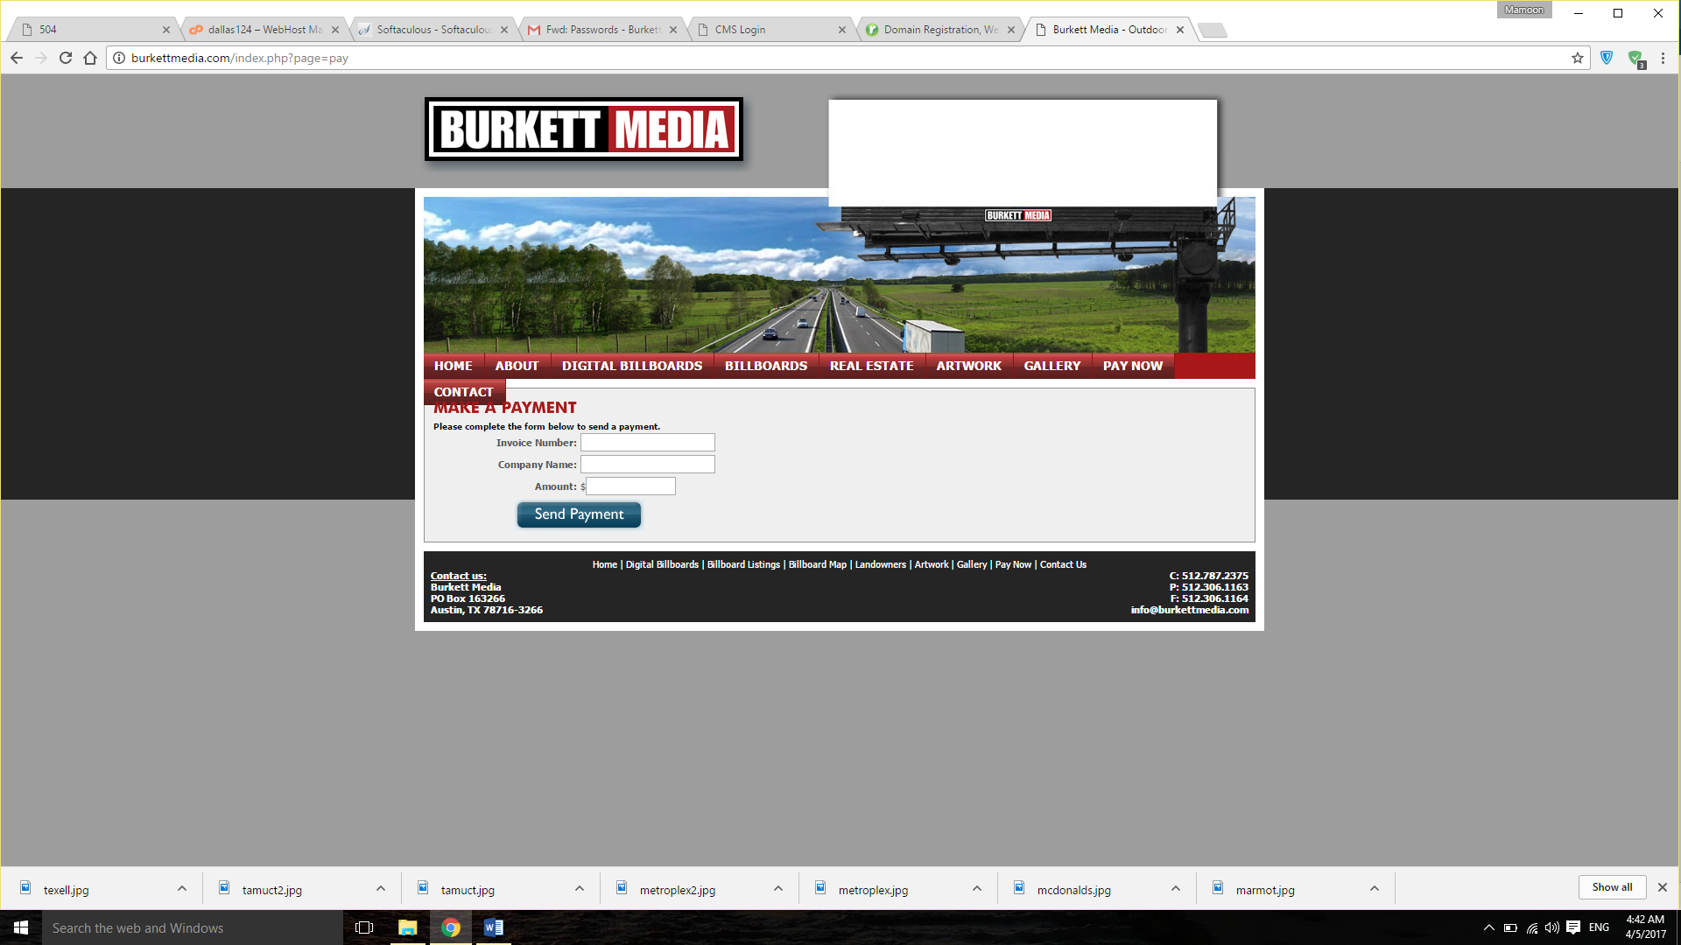

Contact
